Implement Linear and Logistic Regression

**a) Linear regression**

# CODE:

# Sample data

heights <- c(150, 160, 165, 170, 175, 180, 185)

weights <- c(55, 60, 62, 68, 70, 75, 80)

# Create a data frame

data <- data.frame(heights, weights)

# Fit a linear regression model

linear_model <- lm(weights ~ heights, data = data)

# Print the summary of the model print(summary(linear_model))

# Plotting the data and regression line plot(data$heights, data$weights,

main = "Linear Regression: Weight vs. Height", xlab = "Height (cm)",

ylab = "Weight (kg)", pch = 19, col = "blue")

# Add regression line abline(linear_model, col = "red", lwd = 2)

# OUTPUT:

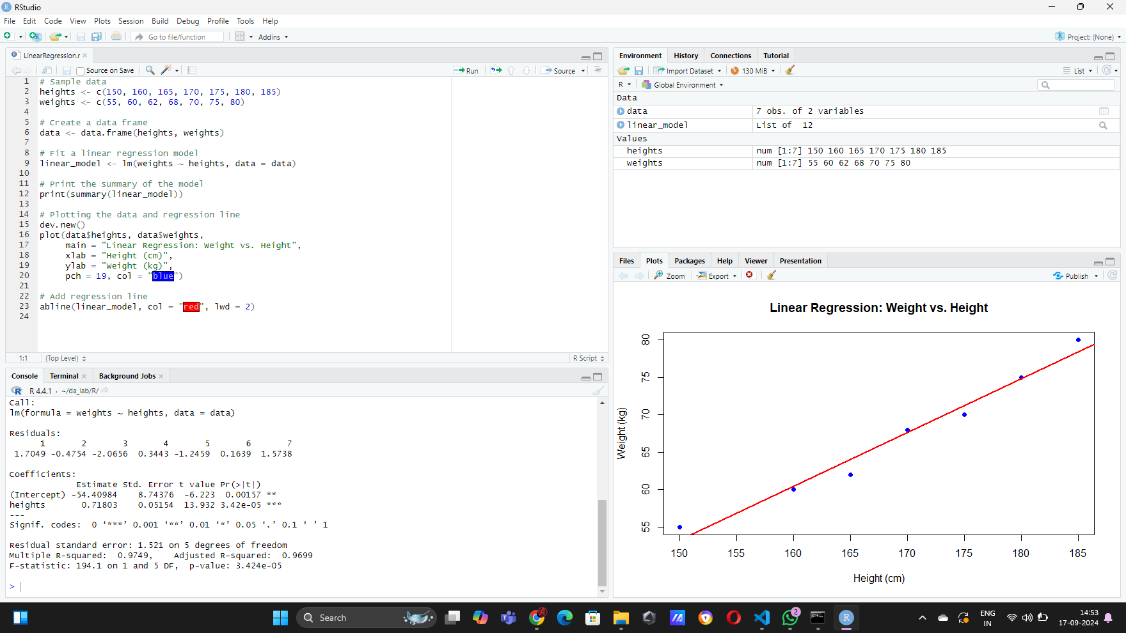

## a) LOGISTIC REGRESSION CODE:

# Load the dataset data(mtcars)

# Convert 'am' to a factor (categorical variable)

mtcars$am <- factor(mtcars$am, levels = c(0, 1), labels = c("Automatic", "Manual"))

# Fit a logistic regression model

logistic_model <- glm(am ~ mpg, data = mtcars, family = binomial)

# Print the summary of the model print(summary(logistic_model))

# Predict probabilities for the logistic model

predicted_probs <- predict(logistic_model, type = "response")

# Display the predicted probabilities print(predicted_probs)

# Plotting the data and logistic regression curve plot(mtcars$mpg, as.numeric(mtcars$am) - 1,

main = "Logistic Regression: Transmission vs. MPG", xlab = "Miles Per Gallon (mpg)",

ylab = "Probability of Manual Transmission", pch = 19, col = "blue")

# Add the logistic regression curve

curve(predict(logistic_model, data.frame(mpg = x), type = "response"), add = TRUE, col = "red", lwd = 2)

# OUTPUT:

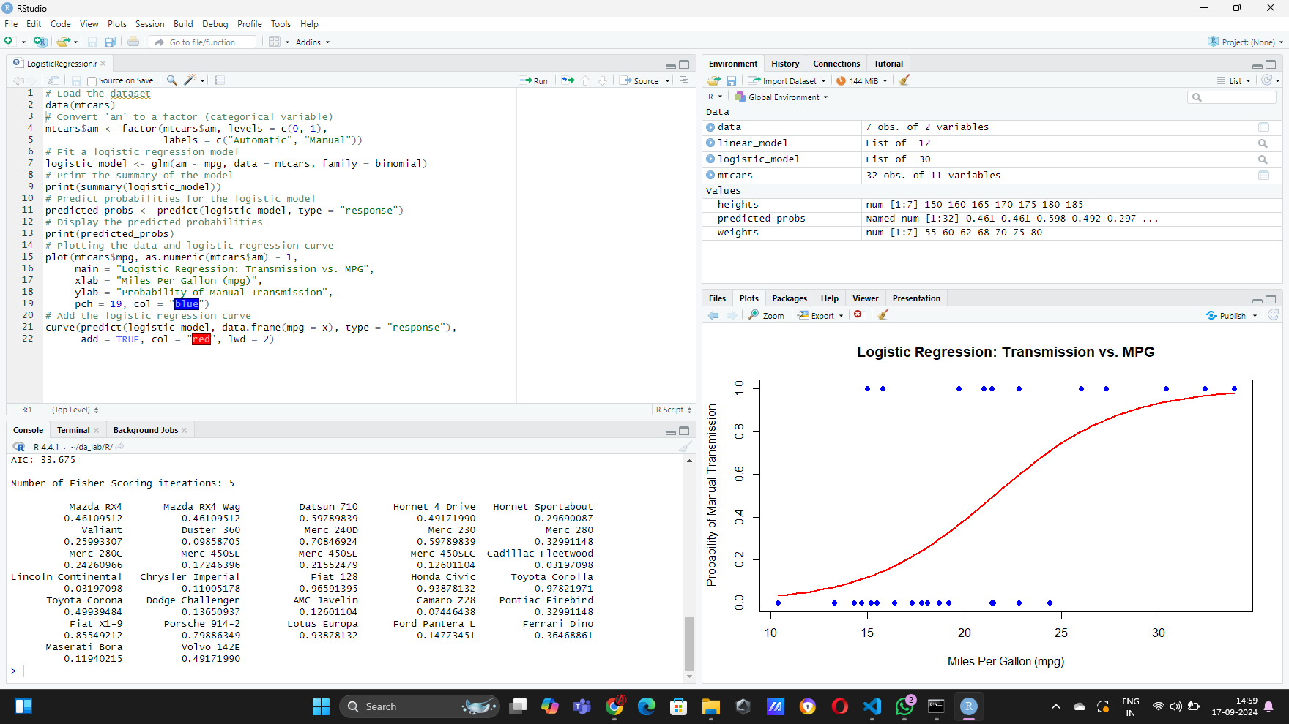

**RESULT:**

Linear and Logistic Regression is implemented successfully.